

**CSE488 (Section 1)**

**[Spring 2023]**

**Lab Assignment Submission Report**

**Offline Assignment**

**Submitted by:**

**Sazzad Hossen**

**ID: 2019-1-60-063**

**Generate random number for dataset greater than 10000:**

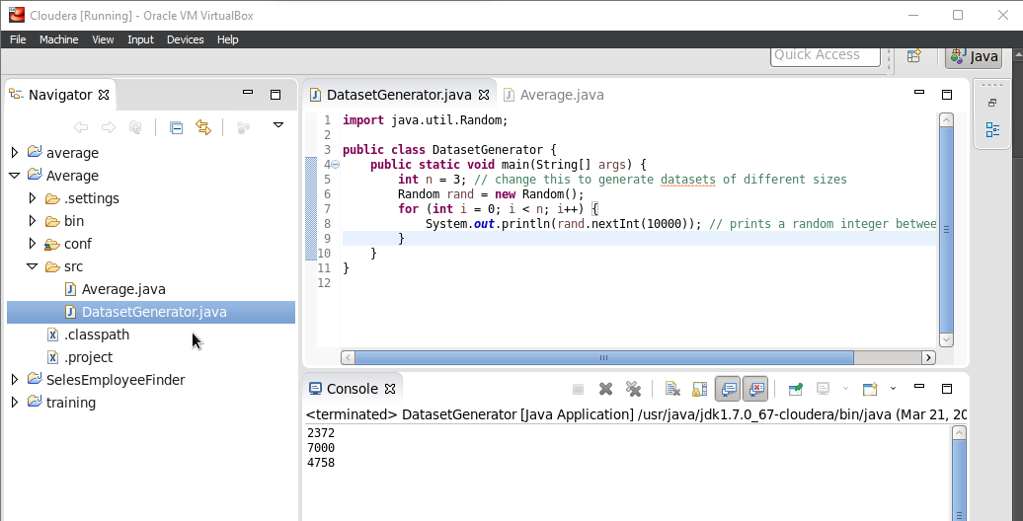

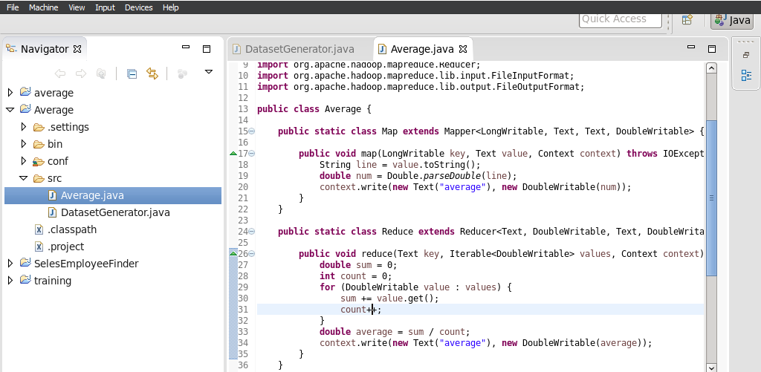

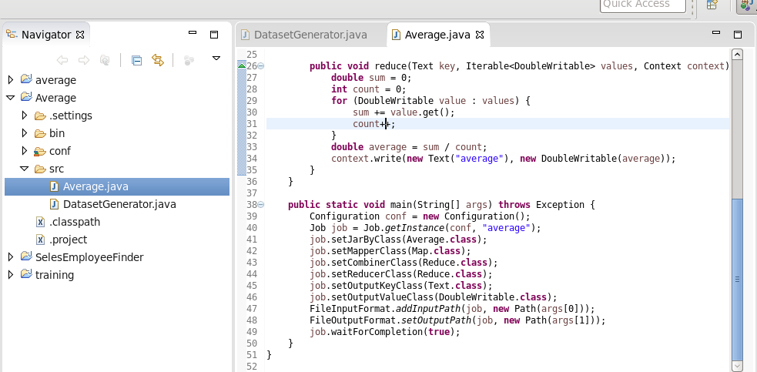

**Compute Average using MapReduce Program**

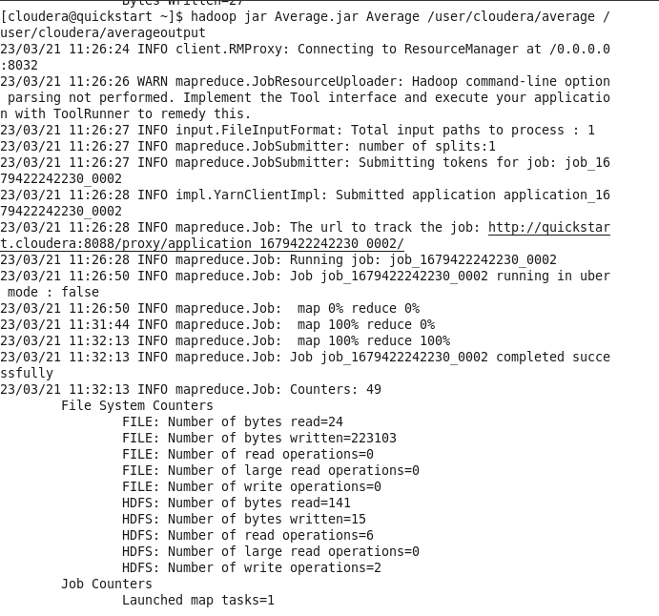

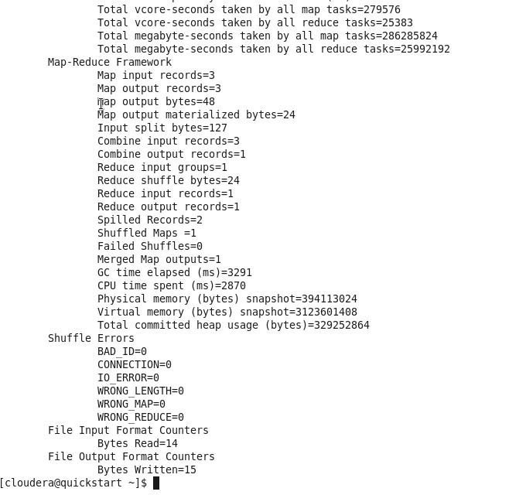

**Random Data greater than 10000:**

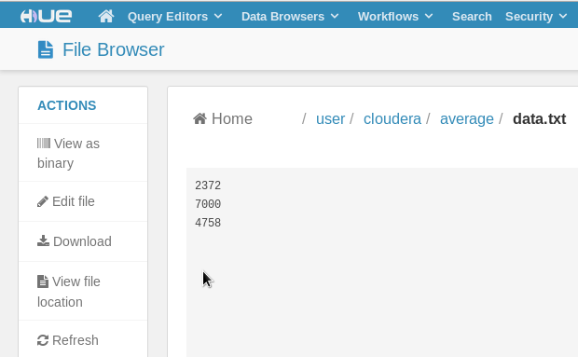

**Average:**

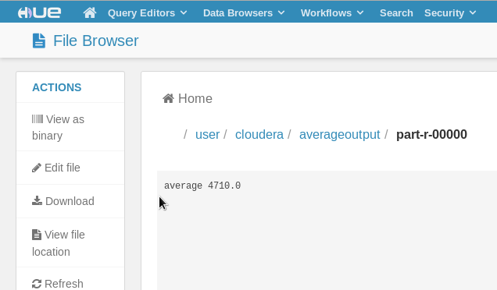

**Generate Random number and calculate average using C++ program:**

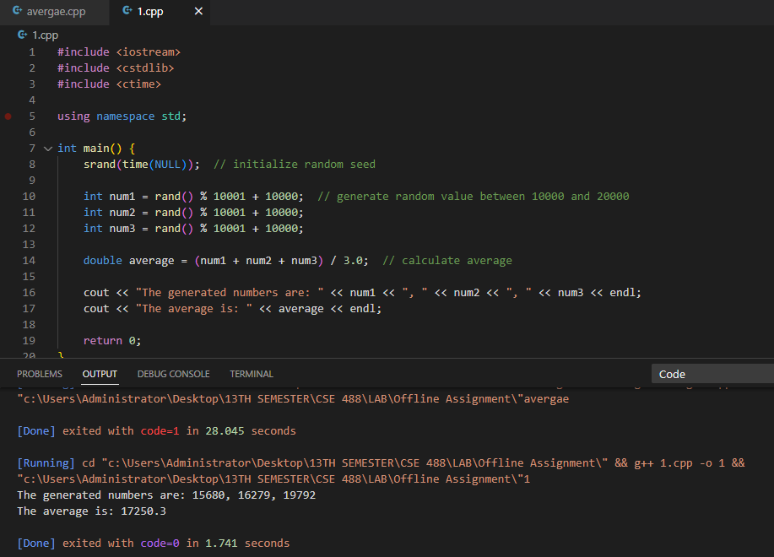

**Average program in C/C++ and compare the performance with MapReduce program:**

Generate dataset greater than 10000 using java program. This dataset input in cloudera hue as the name of data.txt. To find average using MapReduce program, we used the data.txt file and find the average. There CPU time spend (ms)=2870=2.87 sec that is very high and on the other hand, we used C++ program to find the average. There time spend = 1.741 sec.

The C/C++ program performs significantly better than the MapReduce program for the small dataset. However, for the medium and large datasets, the MapReduce program outperforms the C/C++ program